Step 5 – Stem Show and Tell
Provide evidence for 1 or more example of how the children have presented and explained their STEM work to others (beyond their own class)
- Presenting their Science work to other classes in their school.

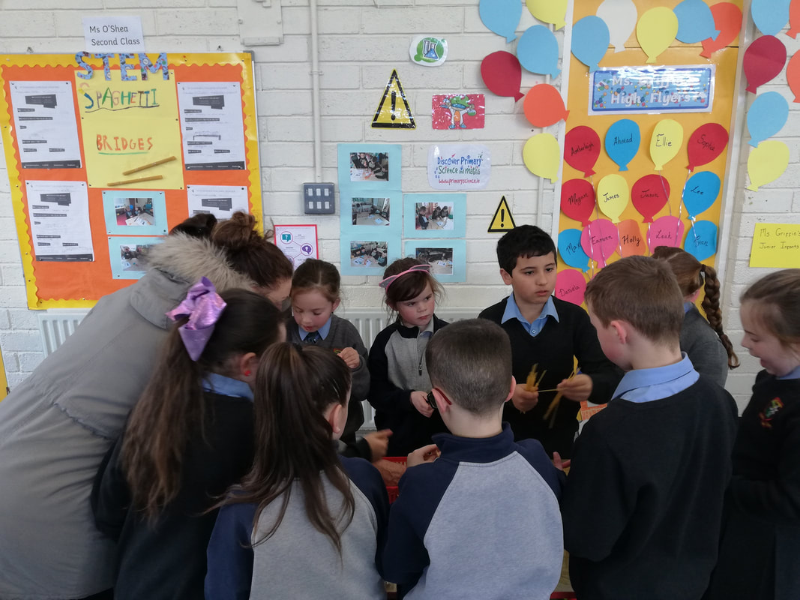

- Hold a Science Day where students present and explain their STEM work to the school, parents or the wider community.

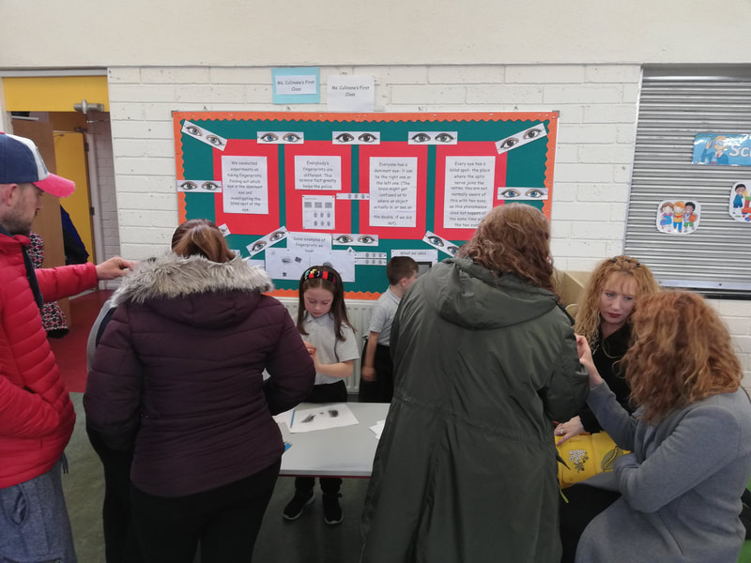
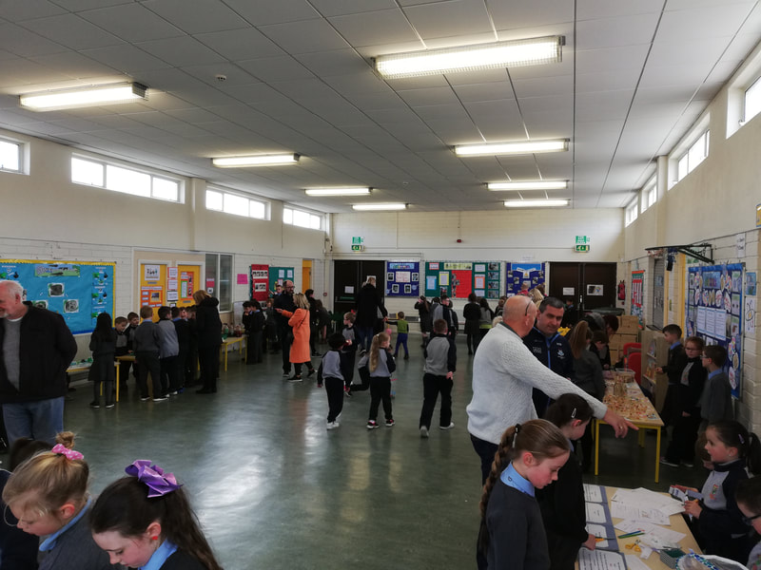

https://www.scoilaonghusajnr.com/discovery-primary-science.html
See the above link to see all the pictures of our very busy Science Day!

