Discover Primary Science Log of evidence
Step 1 –Science
Provide evidence of the children engaging in science activities.
One hands-on investigation from each of the four curriculum strands - Living things, Energy and Forces, Materials and Environmental awareness and care
- Living Things 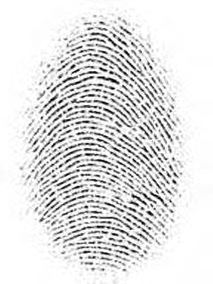
Myself – Fingerprints, Dominant Eye, Blind Spot (Ms.Cullinane’s First Class)
We conducted experiments on taking fingerprints, finding out which eye is the dominant eye and investigating the blind spot of the eye.
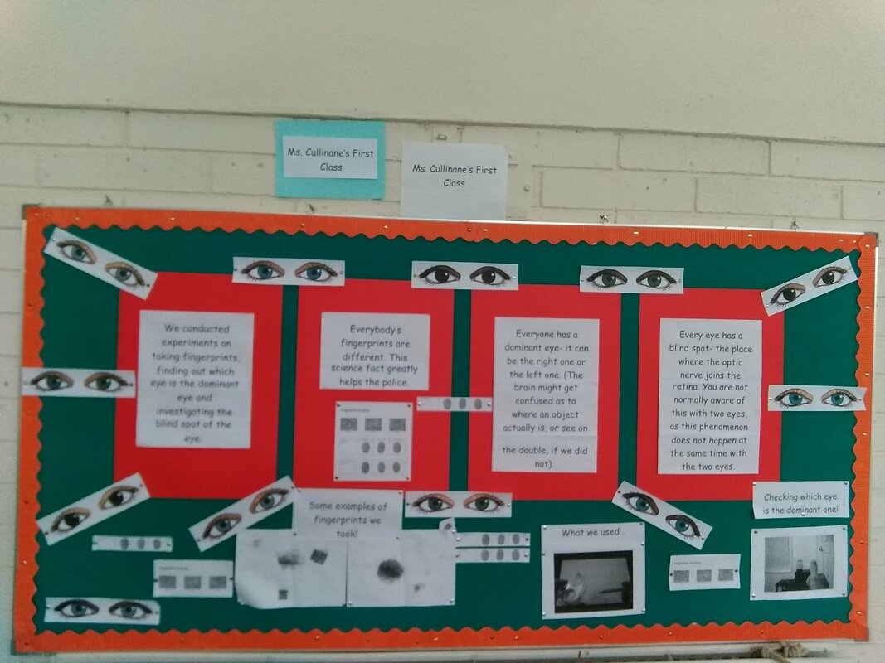
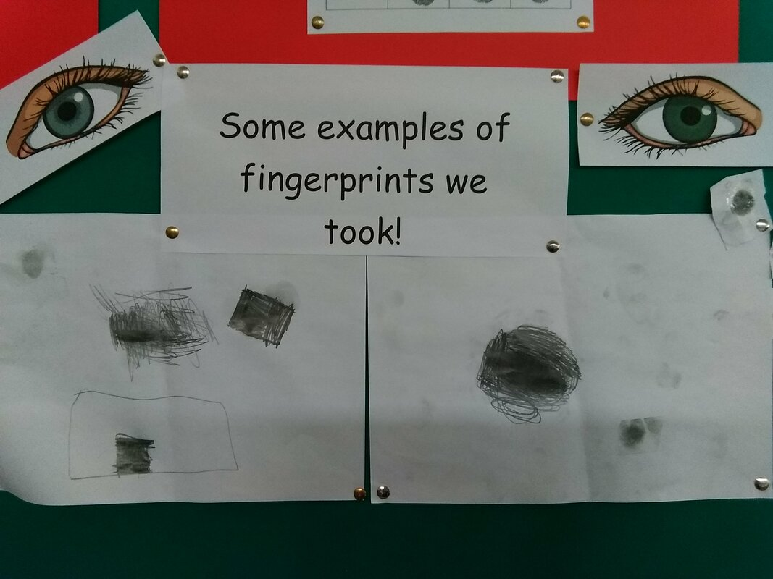

2) Energy and Forces
Paper Helicopters (Ms.Kelly – Senior Infants)
We explored gravity during Science week! The boys and girls made paper helicopters and investigated different ways we could make our helicopter go faster or slower.
We learned that lots of paper clips make it go faster. We learned that a smaller helicopter works better than a big one, but a tiny one doesn’t work at all! We learned that shorter propellers work better than longer ones!
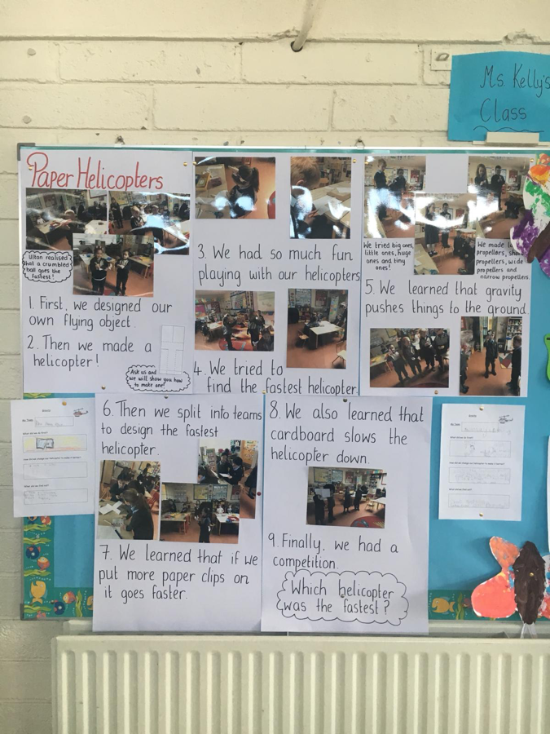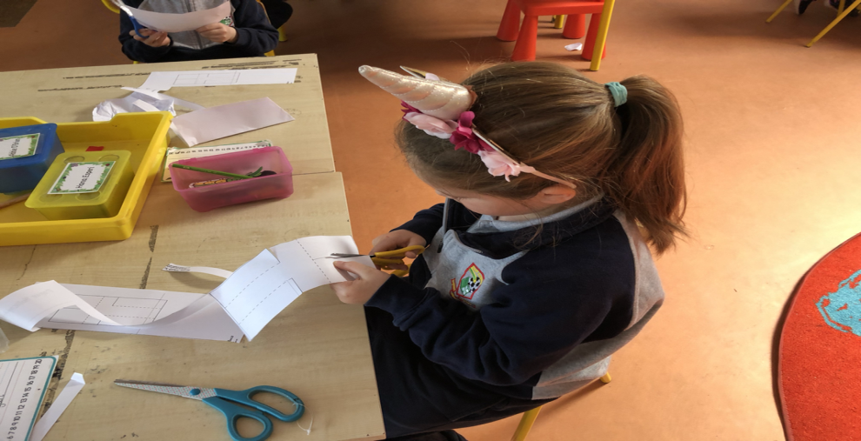

3) Materials
We have been learning about materials. We identified and named everyday materials. Then we worked as scientists to investigate the properties of materials. We looked at and felt the materials to decide if they were strong, hard, soft, rough, smooth, transparent, translucent or opaque. We filled in a table with our findings.

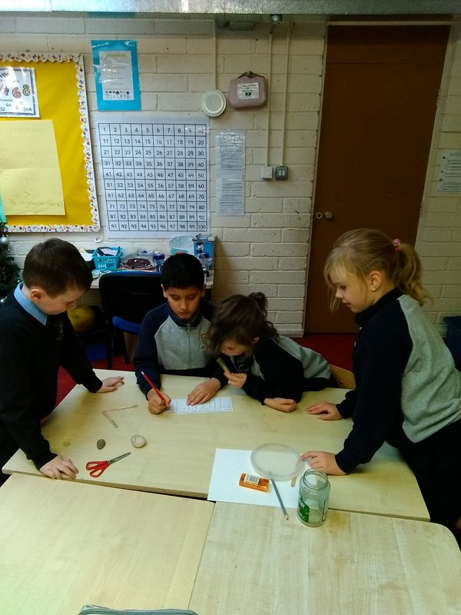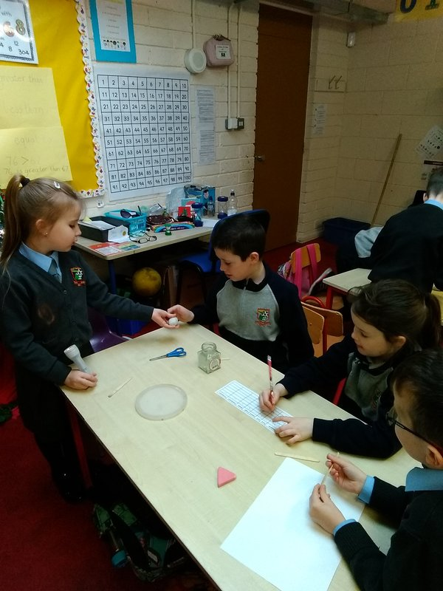
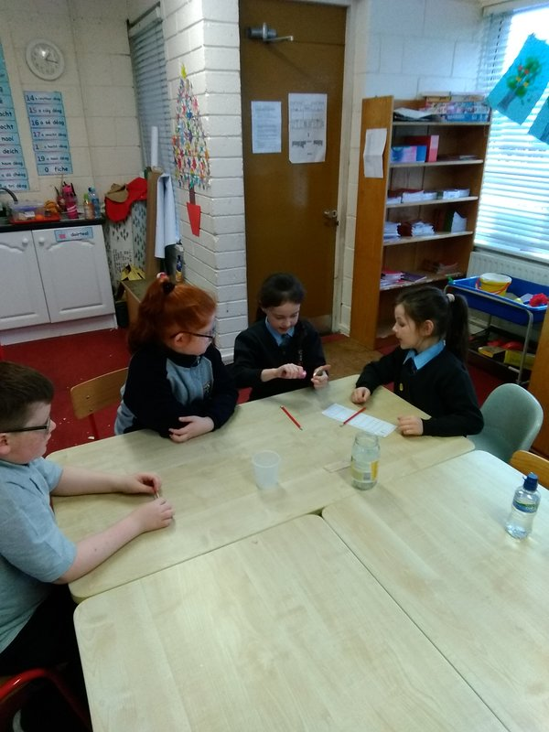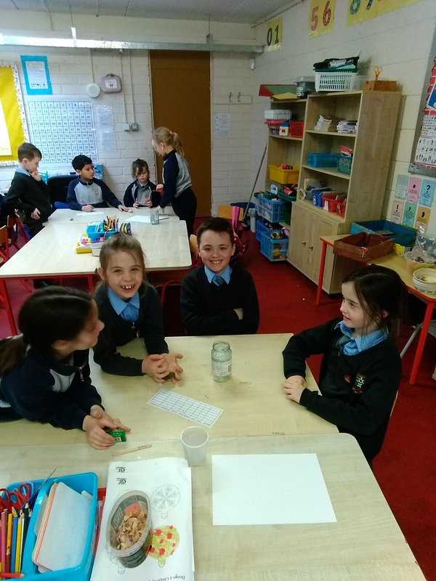
https://www.scoilaonghusajnr.com/ms-oshea.html
4) Environmental awareness and care
Life Cycle of the Frog (Ms. Griffin Junior Infants)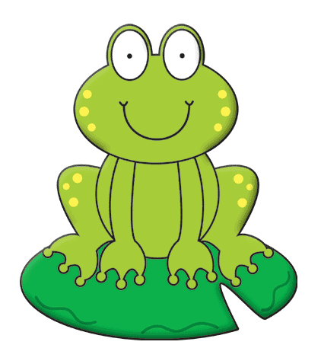
Ms Griffin’s junior infants were eager to study the life cycle of a frog after a visit to the pond where we were lucky enough to see heaps of real life frogspawn! We didn’t just want to study the life cycle of the frog, we wanted to bring it to life by making a 3D model! We set about constructing our model out of recyclable materials by making frogspawn using cupcake cases and paint. Next, we made tadpoles using egg cartons and paint. After the tadpoles, we made frog lets using egg cartons, glue and green paper. Finally we made our frogs using air dough, paint and green paper!
We stuck the four stages onto card in the right order and then we labelled them. We loved the fact that this science project provided us with some art and literacy opportunities too! We had great fun at the science day explaining the life cycle of the frog to the visitors and then testing them using our life cycle of the frog puzzles! Take a look at some of the steps to creating our 3D models below.

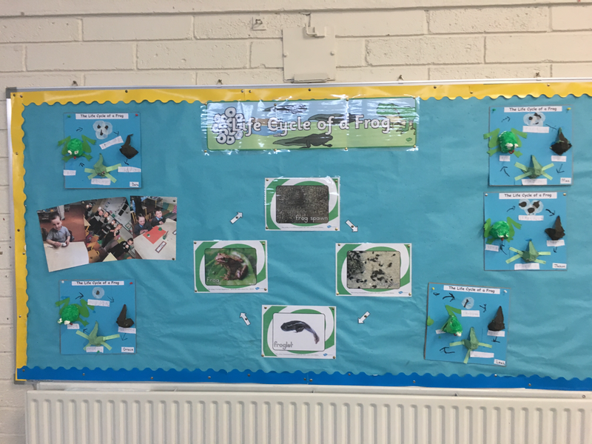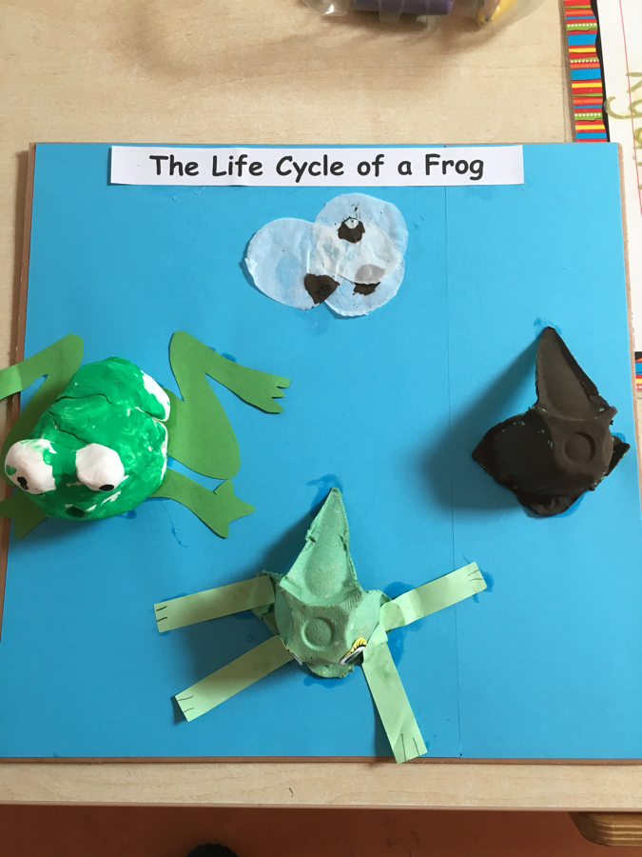

To see this experiment in more detail and to see other amazing experiments go to https://www.scoilaonghusajnr.com/stem.html

AND two or more of the following:
- Invite a Science Speaker to your school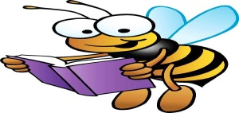
As part of Eco Week 2019 some children from 2nd classes took part in a “Bee Aware” workshop and planting/Scavenger hunt. The workshop helped the children to understand the importance of Bees –pollinators and how we all must take steps to increase our bee populations. We need bees in order to grow our fruit and vegetables, and to make sure that our countryside has lots of beautiful wild flowers.
Bee Aware Certificate! For more pictures of our 2nd classes planting bee friendly pollinators go to
https://www.scoilaonghusajnr.com/guest-speakers.html

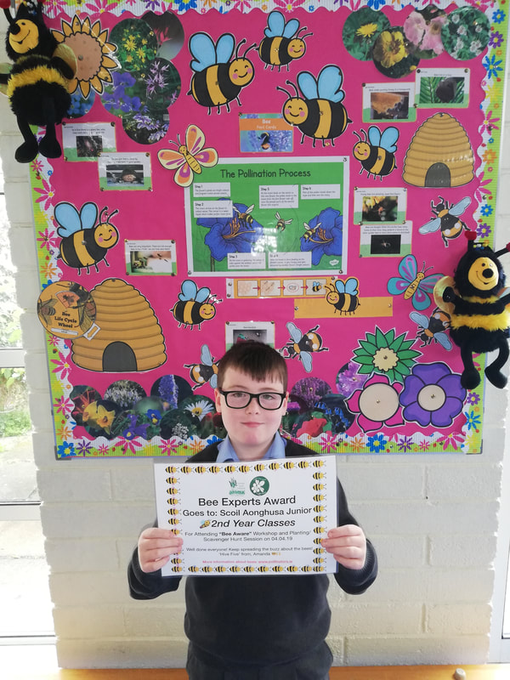

- Take part in Science week 2018
12th – 18th November 2018
Dyed flowers science experiment (Junior Infants Ms. Murphy)
The children investigated what would happen if flowers were placed in different coloured water, as well as regular water. The children made predictions on what might happen. Some of their suggestions were that nothing will change, the flowers will change colour and the flowers will grow. The children were amazed when they came in the next day to discover some of the flowers had changed colour. The children decided that the flower's petals changed colour because the water was travelling up into the petals. They also agreed that the petals turned the same colour as the water they were in.
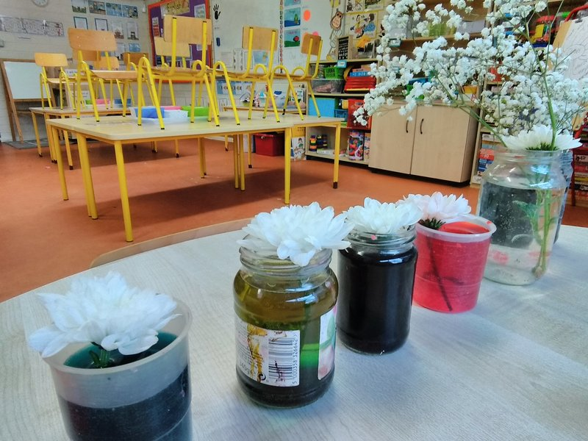

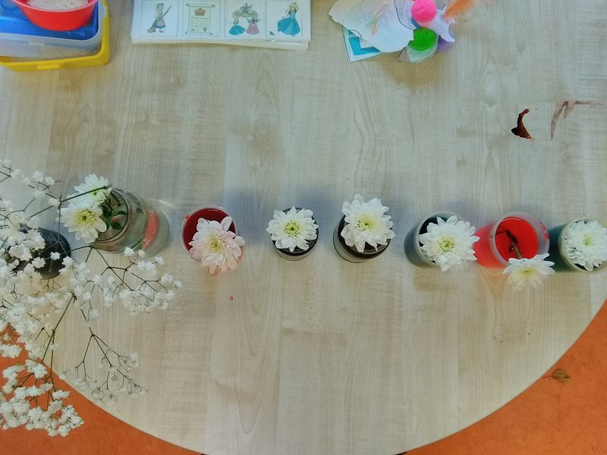

https://www.scoilaonghusajnr.com/ms-murphy.html
3) Visit a SFI Discover Centre
Our First and Second Classes attended a workshop in Discover Science Centre in Dublin Zoo.
Our certificates!
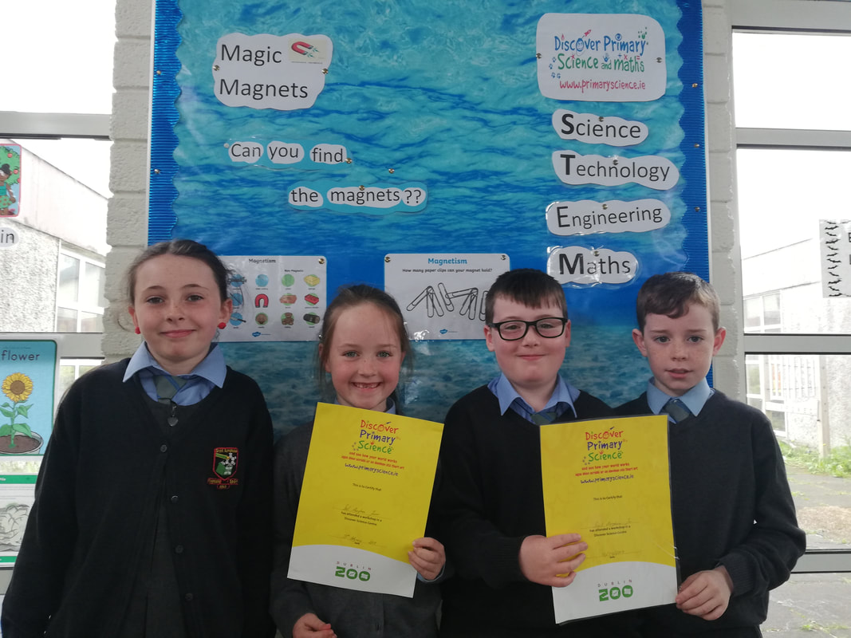
For more pictures see https://www.scoilaonghusajnr.com/ms-smith.html

