Step Two – Technology
Provide evidence for 2 or more examples of how the children used technology as part of their school work.
- Develop a blog, website or video
See our school website https://www.scoilaonghusajnr.com
This website has just been developed in 2019 and is still a work in progress! We decided to use Weebly which is a Do-it-yourself website builder. Pupils upload photos of their science work, science day and school educational visits with the help of their class teacher.

- Use different materials for design and make projects
Design a safety jacket for an egg (Ms.O’Shea Second Class)
We worked in groups to design a safety jacket for an egg. Then we had fun testing our jackets! Most of our eggs survived but some were not so lucky. We found out that the eggs needed to be secure within the jacket to survive the drop.
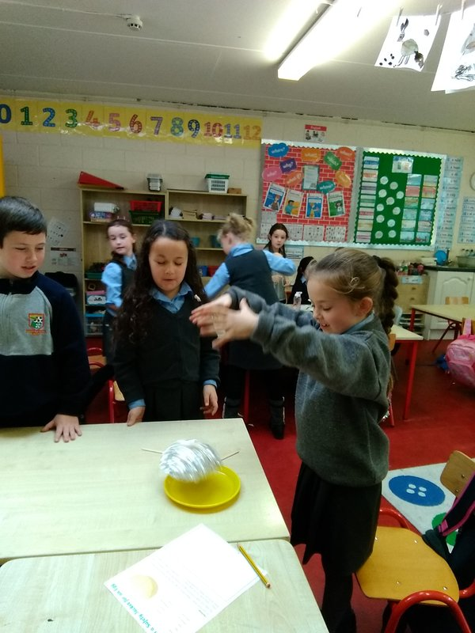
See http://www.scoilaonghusajnr.com/ms-oshea.html for more pictures and information!

- Design animal print Tee-shirts (Ms. Smith Second Class)

We designed some animal print t-shirts in preparation for our trip to the zoo!
We created stamps using foam and cardboard.
We used special fabric paint to paint the stamps and then printed them on to our t-shirts.
Don't they look amazing???
What animal prints do you see?

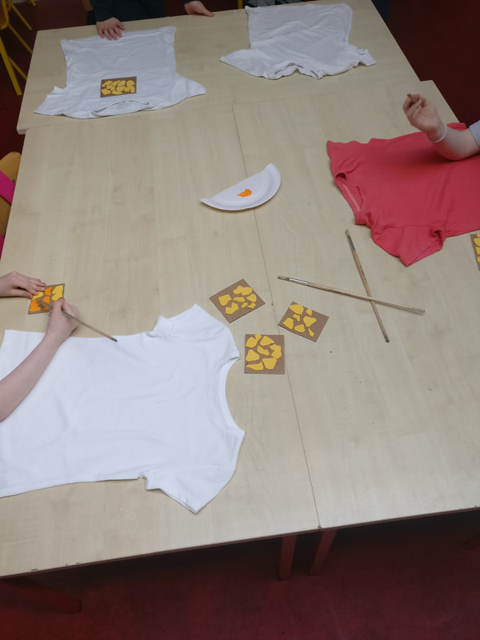

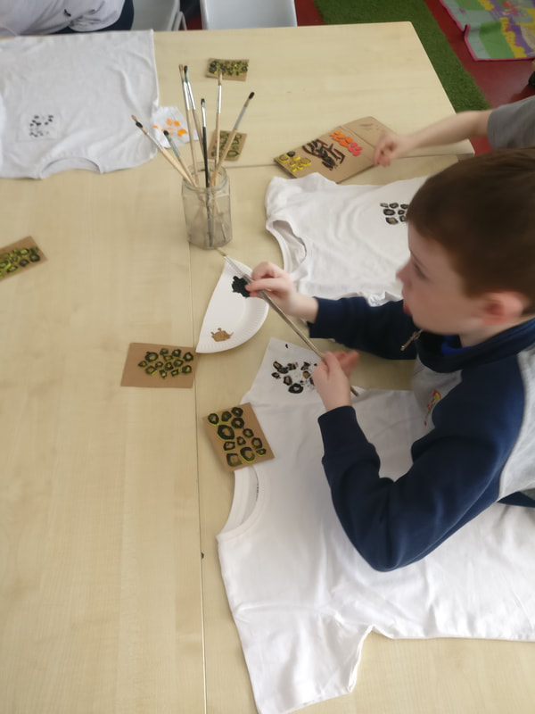
See https:// www.scoilaonghusajnr.com/ms-smith.html for more pictures

- Take part in Coding using ipads
As we are a junior school we decided to introduce ScratchJr which is coding for young children. We started to program our own interactive stories. We decided to work in pairs.
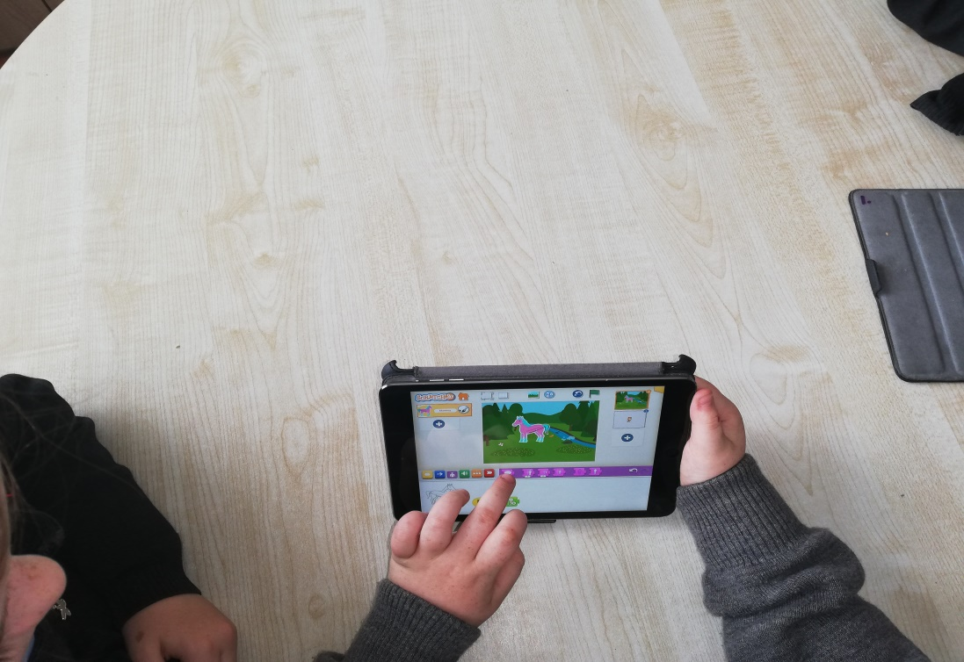
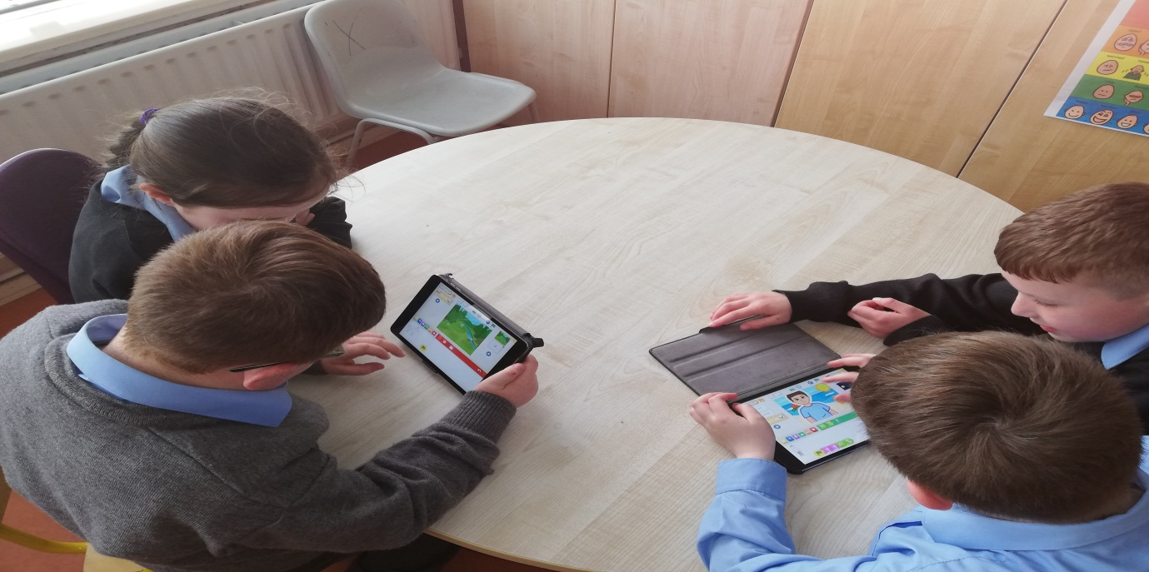
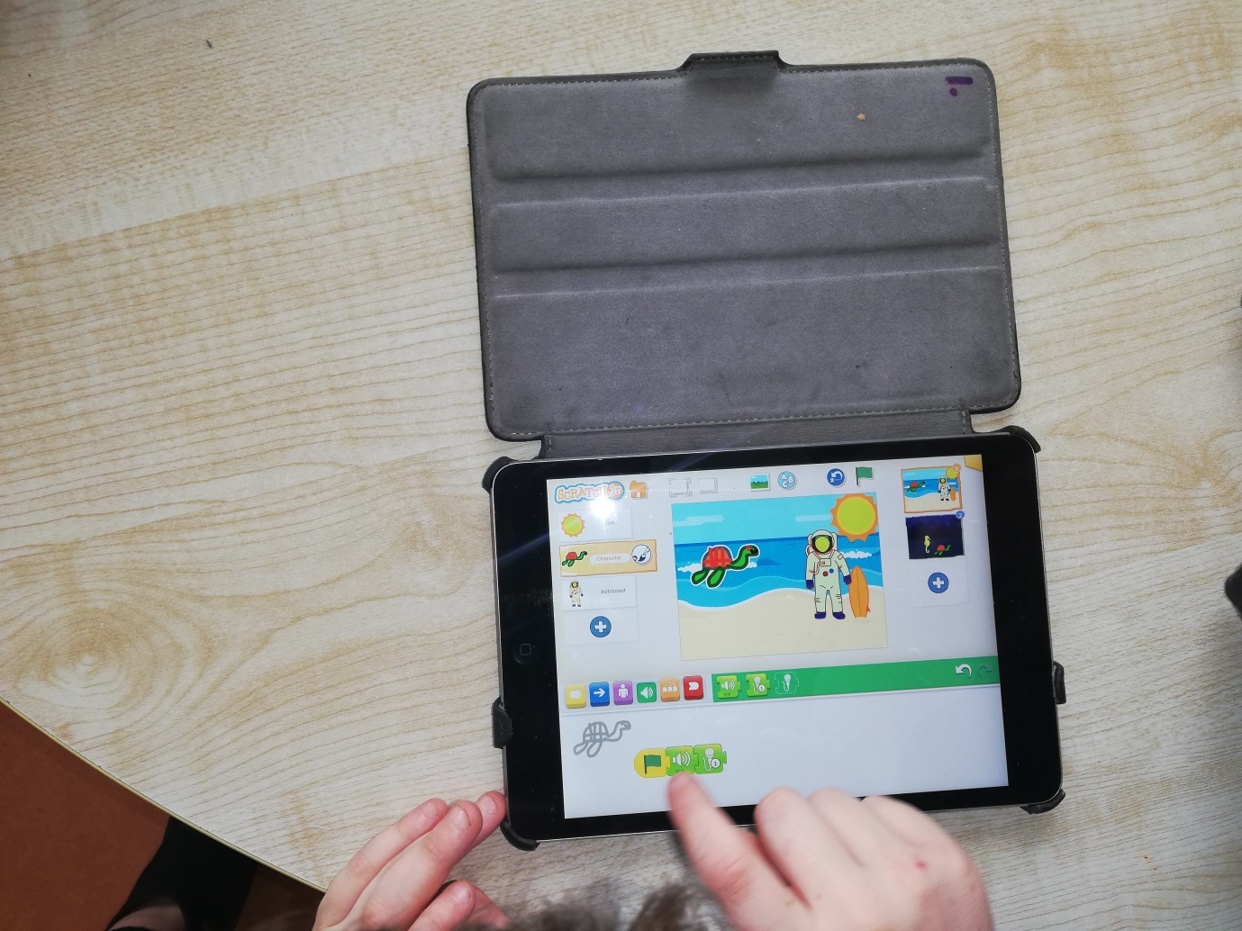
In the process, the children learn to solve problems, design projects and express themselves creatively on the computer.

