Step 3 – Engineering
Provide evidence for 2 or more examples of how the children investigated engineering in class or the local area
- Design a boat (Ms. Keogh First class)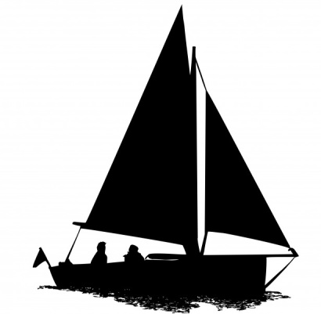
Our class were asked to design a boat made from playdough ⛵.At first, we had a discussion about things that float and things that sink. We guessed that our ball of playdough would sink because it was heavy- we were right! The playdough sunk to the bottom of our basin ⚓
We then decided to roll the play dough into a sausage shape. This also sunk ⚓
After exploring different ways to shape the playdough we figured out that if we shaped the playdough into a cup shape with smooth walls, the playdough boat would float! ⛵
This experiment took a lot of practice but we had lots of fun! We even managed to carry some passengers in our boats ⛵
The boys and girls did an excellent job at explaining their experiment to everyone on science day! 👩🏼‍🔬👨🏻‍🔬⛵️
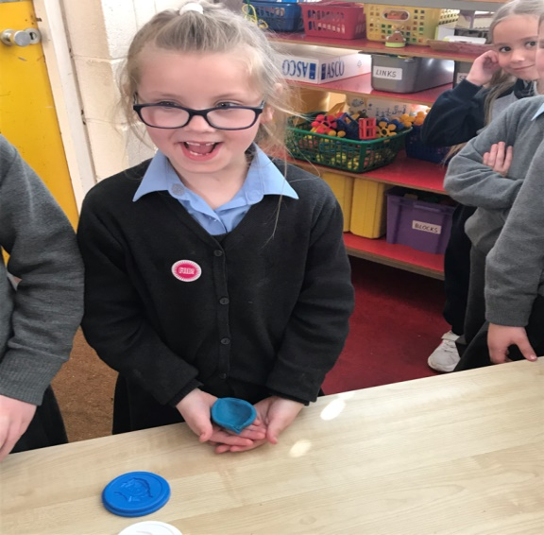
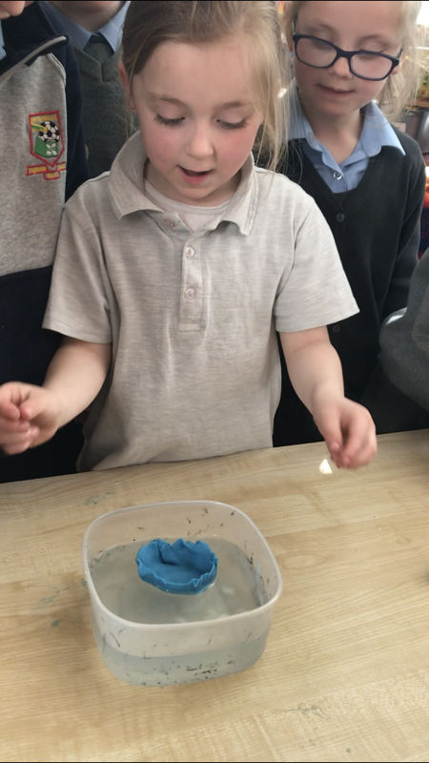
http://www.scoilaonghusajnr.com/stem.html

- Design a Bridge (Mr.Kennedy Second Class)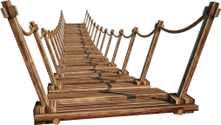
Materials: Paper, coins, books (to make two banks for a river) and counting cubes.
Our Task: To explore how different materials and shapes affect the strength of a bridge.
Preparation: Prior to completing the experiment, we investigated images of many different types of bridges. We looked at the materials used to make the bridges and the different shapes used in making the bridges. We discussed what we thought each part of the bridge was there for and what work it was doing.
Examples of questions that were used to guide our discussion are outlined here:
What is a bridge? Where would you find a bridge? What makes a good bridge? Who passes a bridge on their way to/from school?
Experiment: We then began our experiment. We used our school books to make the banks of the river. We used A4 paper to make the bridge to cross from one bank to the other. Cubes/counters were used to measure the strength of the bridge. The strength of each bridge was recorded by the children using their clipboards. We really felt like engineers.
​Have a look at some of the pictures of us carrying out our experiment.

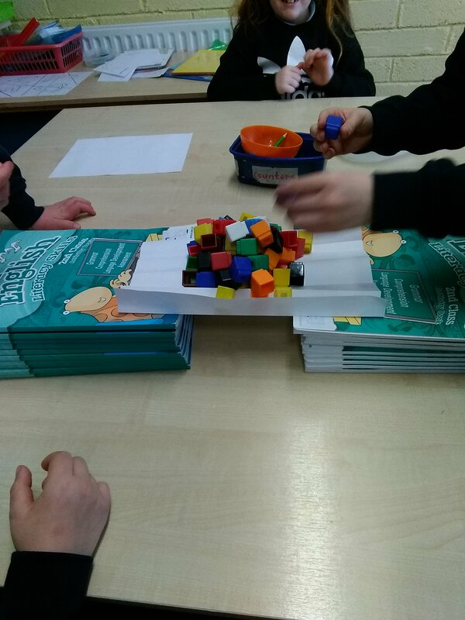

For more photos go to http://www.scoilaonghusajnr.com/stem.html

- Use the Engineers Week 2019 classroom pack
Spaghetti Bridges (Ms O’Shea Second Class)
The brief we were given was to construct a free standing bridge out of spaghetti, strong enough to support a 1/2KG bag of sugar. We were only allowed to use spaghetti, elastic bands and tape. We found out that bracing strands together made them stronger. Some shapes are better at absorbing loads; we found out that triangles are particularly strong. We had great fun experimenting with the spaghetti and making our bridges. We tested the strength of our bridges by placing a 1/2 bag of sugar on them.
We learned that bridges manage two important forces: compression and tension – pushing and pulling. Too much of either and they will buckle or snap.
The children did an excellent job explaining our STEM challenge on Science Day. Take a look at our photos of our challenge and of the fun we had on Science Day.
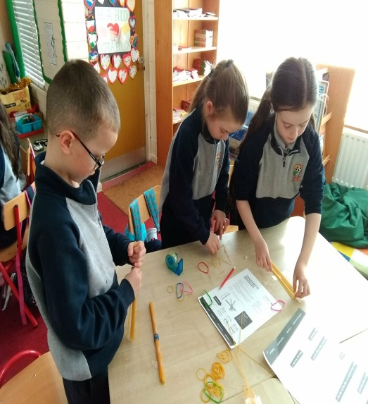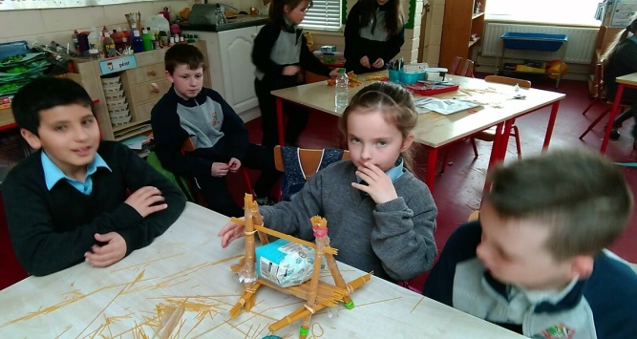
For more photos see http://www.scoilaonghusajnr.com/stem.html

