Step 4 – Maths 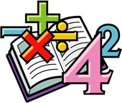
Provide evidence for 2 or more examples of how the children have applied their Maths knowledge and skills in practical ways.

- CANDY CONSTRUCTION IN MS SMITH'S SECOND CLASS!
Materials: cocktail sticks, bamboo skewers, jelly beans, marshmallows.
Our Task: Explore what can be created and constructed with the above materials.
Before delving in to the jelly beans and marshmallows, we made a plan. Each child thought about what they would like to try build and how they would go about it. Some children took some crayons and pencils to help them visualise, others began drawing their ideas on to paper.
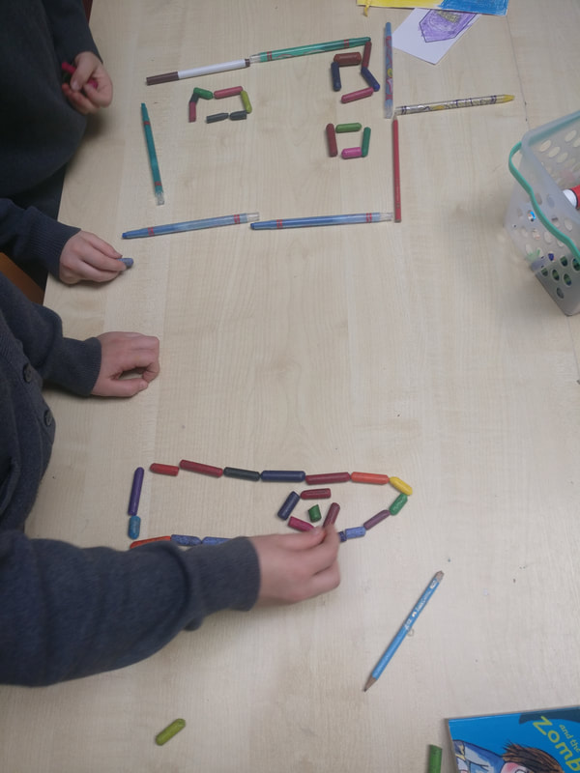
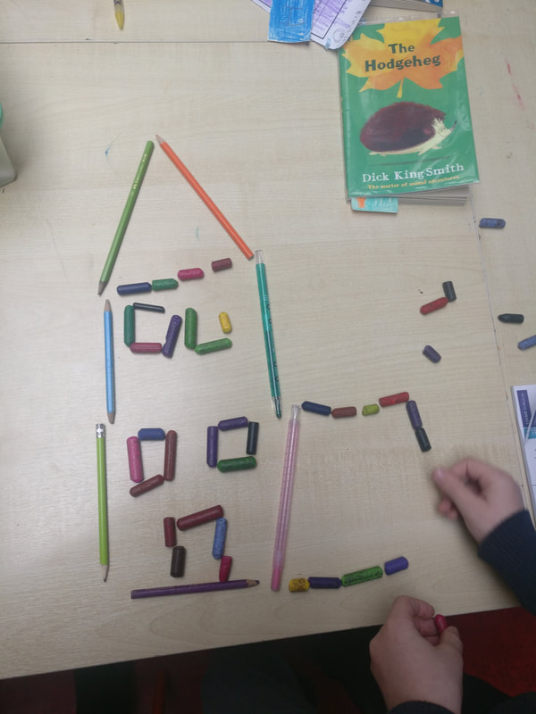
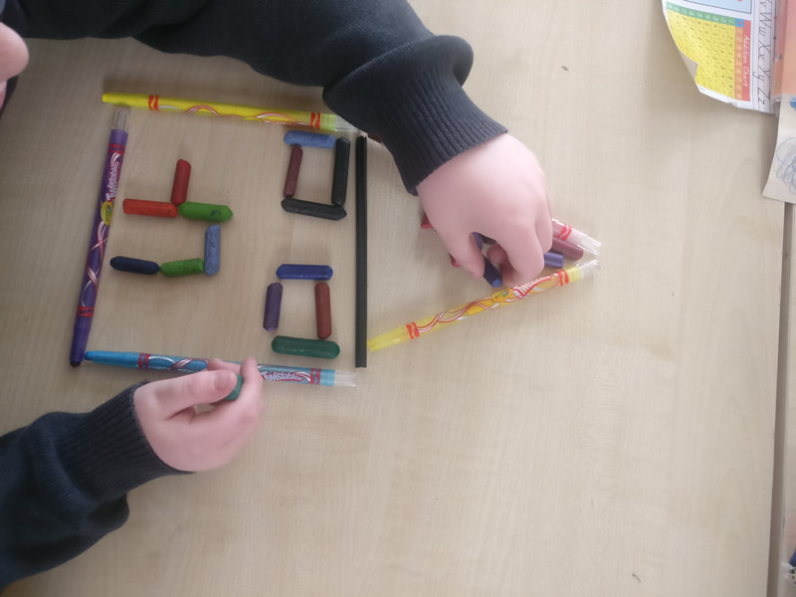
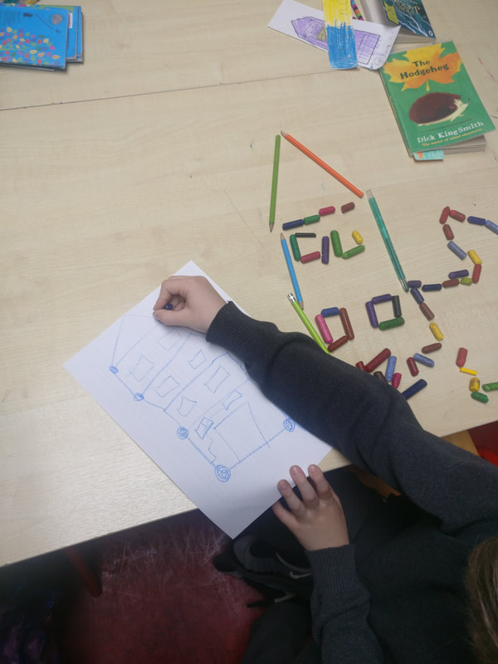
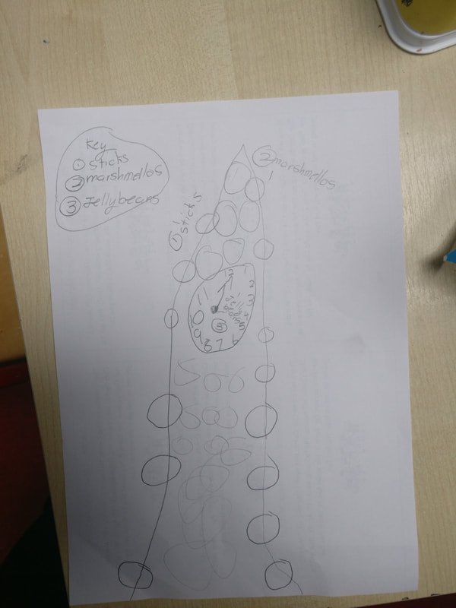
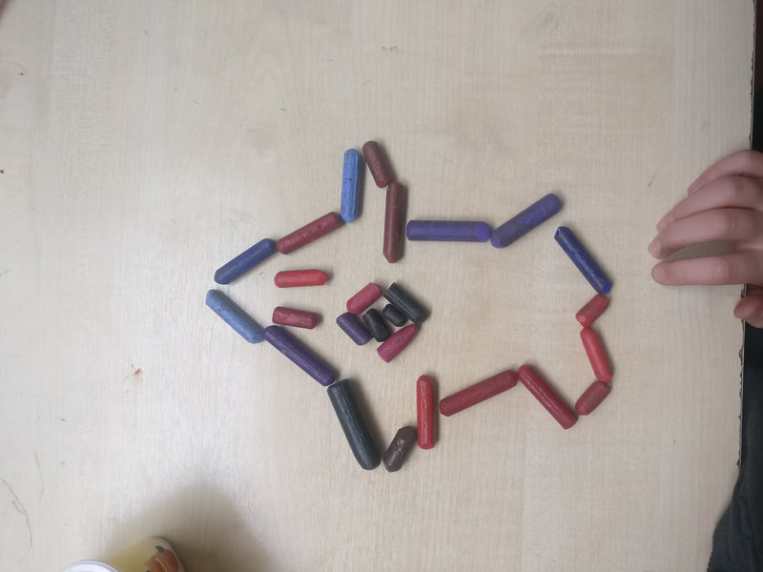
With our plans in place, the next step was to begin experimenting. We gathered our materials (and resisted the temptation to eat everything). The children tried making constructions of all different shapes and sizes.
We explored with 2D vs 3D shapes - what could we do to add extra support to the 3D shapes?
We tried making tall shapes vs short shapes.
We compared the strength of the jelly beans vs the marshmallows at holding the sticks in place and we also compared the long bamboo skewers to the short cocktail sticks, in terms of which made a more secure structure.
Our Findings:
The jelly beans were much firmer than the marshmallows and held the sticks more securely in place.
The long skewers appeared too heavy for the jelly beans or marshmallows to keep in place. We found it hard to make tall constructions with the long skewers.
​We discovered 3D shapes need lots of support and a good base to keep them upright.
The children really enjoyed this challenge and did an excellent job explaining our findings and helping others on Science Day. Take a look at some of our constructions in the photos below.
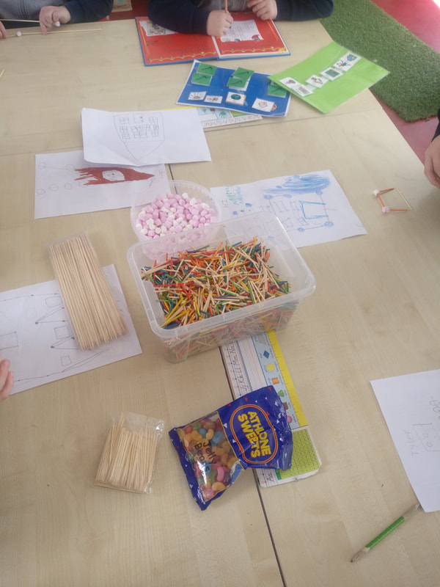
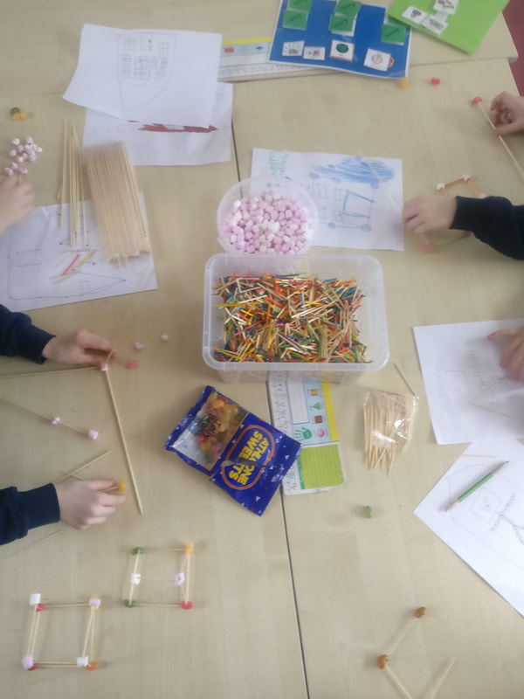
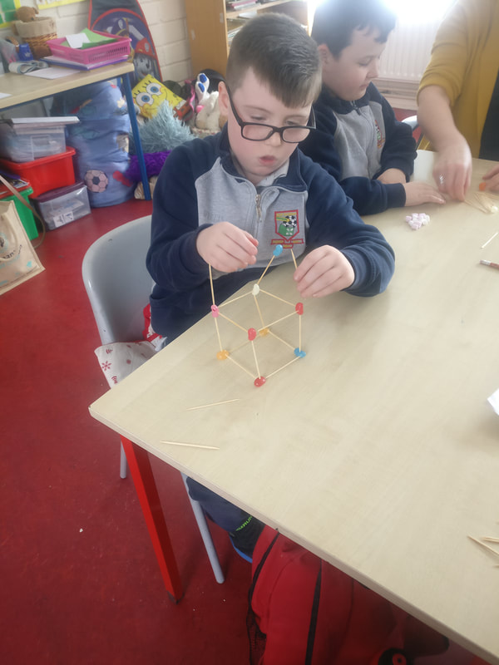
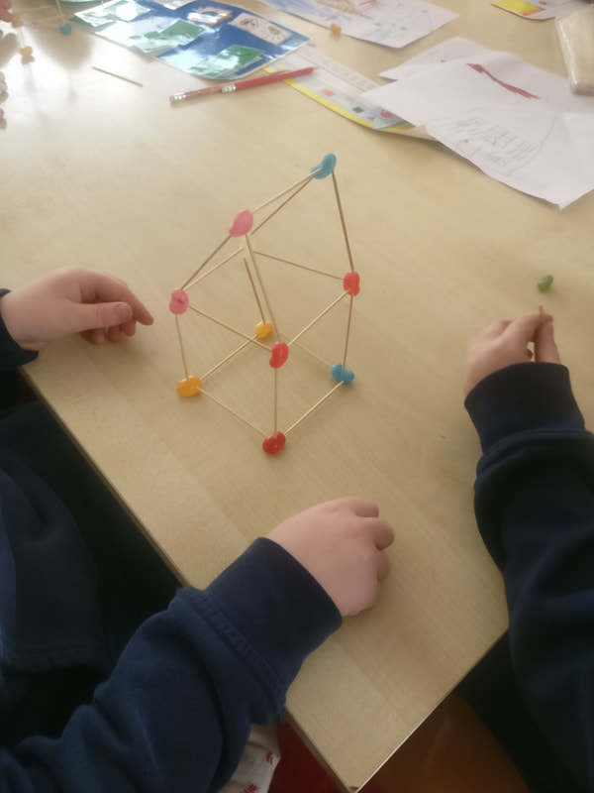
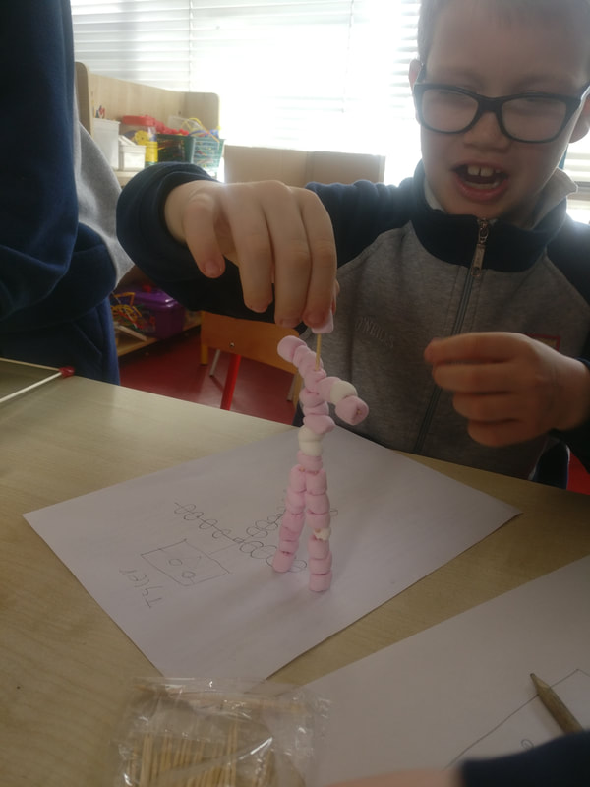
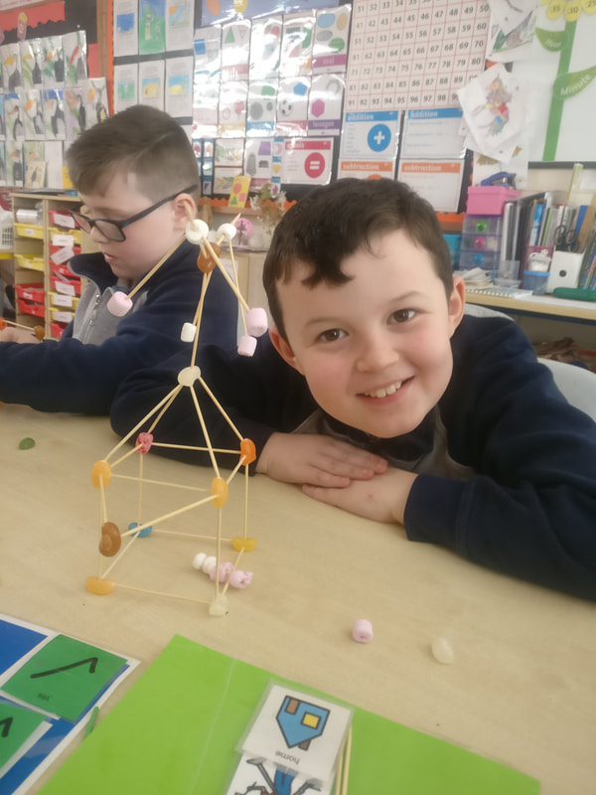
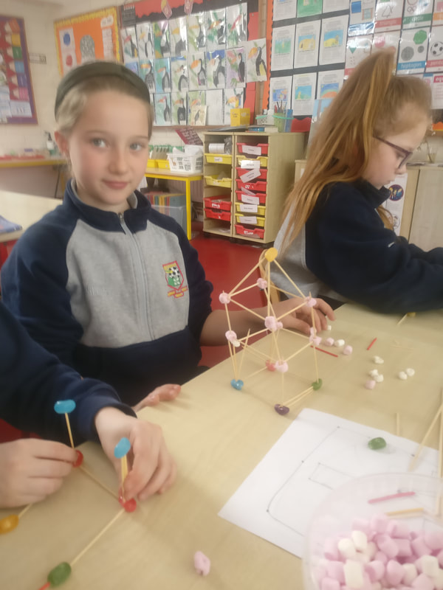
https://www.scoilaonghusajnr.com/stem.html

- Acrobatic Clowns –Balance/weight (Ms. O’Dea)
In Ms O’Dea’s Senior Infants we were exploring balance! We were learning about how weight has to evenly distributed to find the balance. We were making balancing clowns. First we coloured them, then we cut them and then we tried to balance the clowns on our finger. It would not work because all of the clowns weighed the same. We then stuck two coins to the clown’s hands which made the bottom heavier, and as if like magic the clowns balanced on the top of our fingers!
We have also been learning about balance in maths. We have been balancing lots of different objects with cubes.

​ 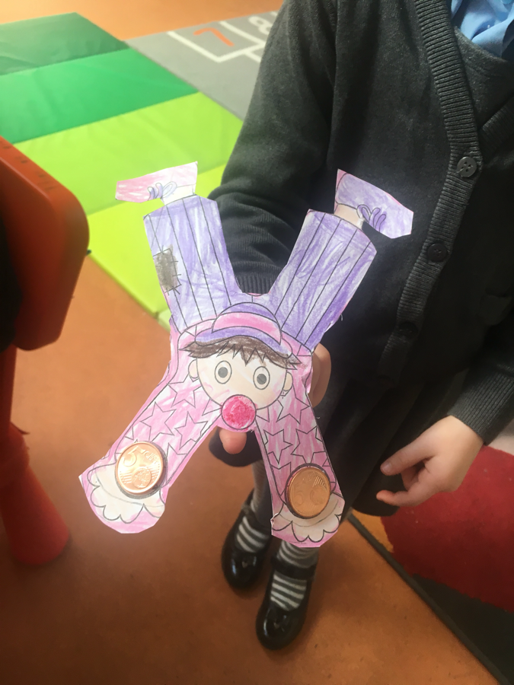
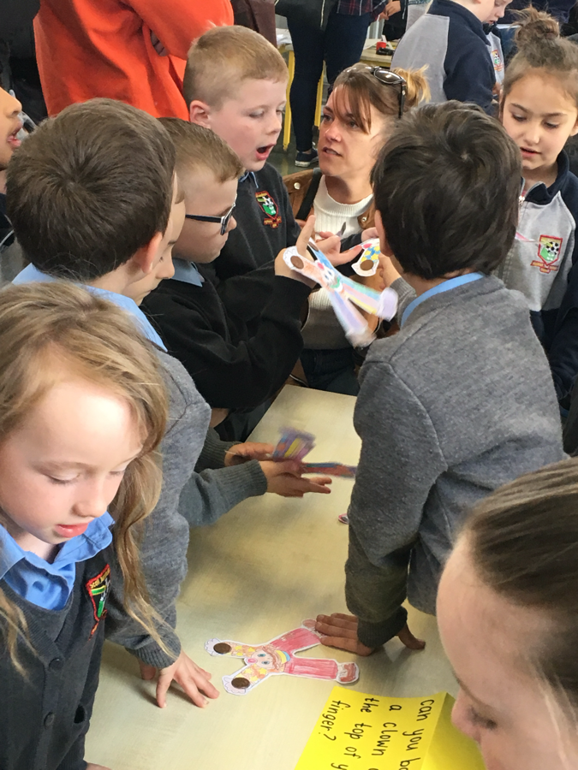
See https://www.scoilaonghusajnr.com/stem.html for more photos.

- Shape Hunt ( Ms. Reid Junior Infants)
On Tuesday 5th March we went on a shape hunt to look for 2D shapes and 3D shapes. We found lots of different shapes inside of the classroom and around the school. Shapes are everywhere! Can you name the shapes in the pictures?

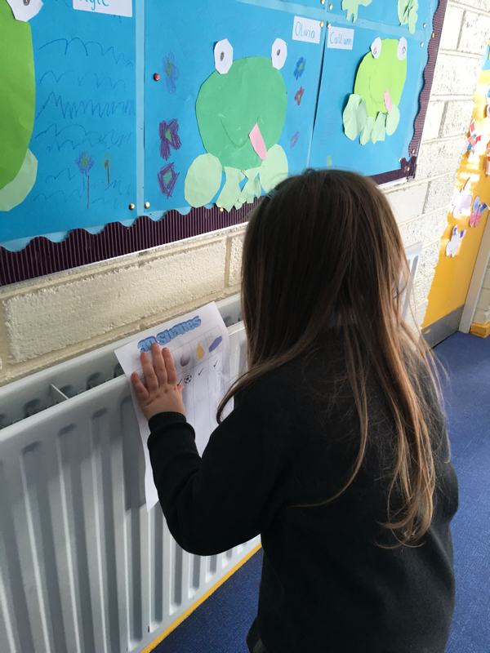
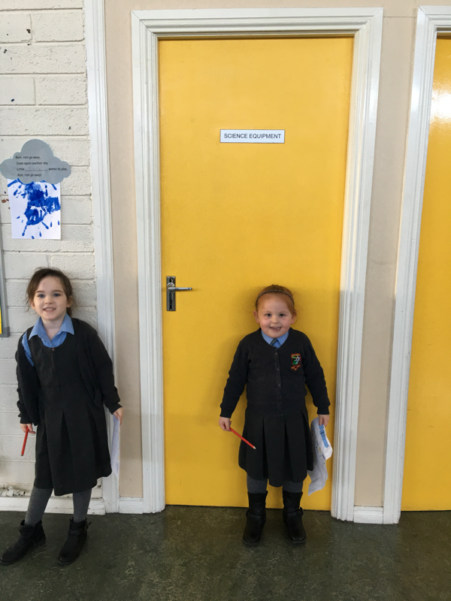
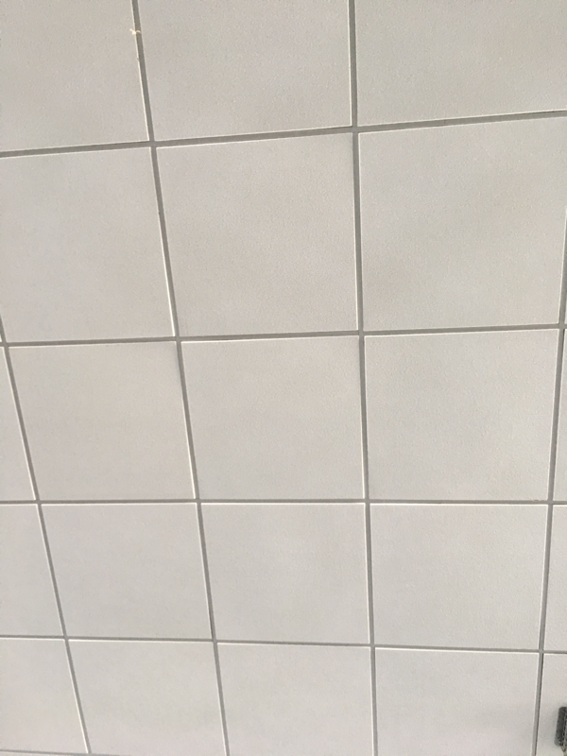

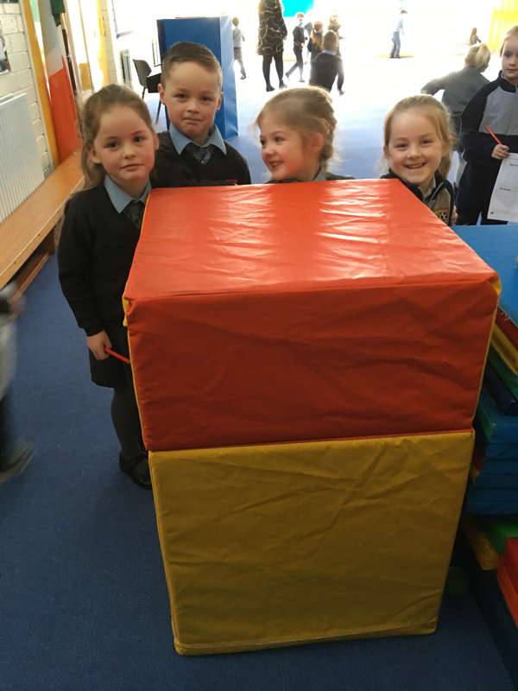
https://www.scoilaonghusajnr.com/ms-reid.html

- Shape Trail

Senior Infants decided to complete a maths trail as part of maths week. As we are a Junior School we decided on a simple shape trail in our local environment – school playground and carpark.

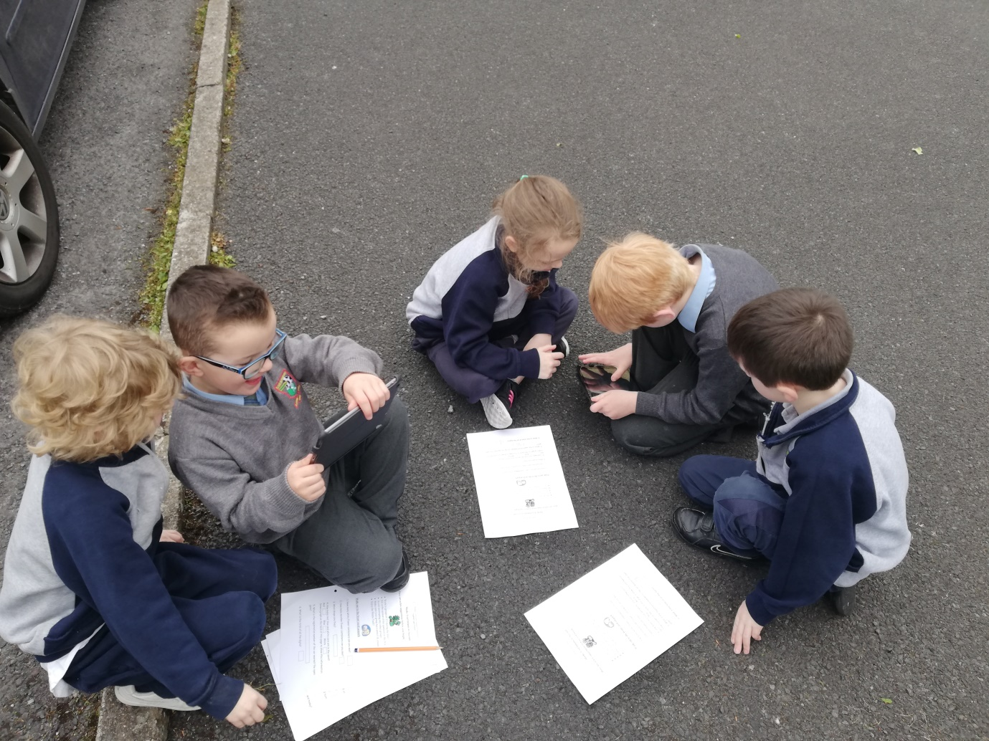
We took pictures of the shapes that we saw!
We also completed a Maths trail worksheet. See the worksheet below.

